FXCop tool:

Code analysis tool

Runs on .net DLLs using reflections.

Here we check two things:

1. Existing rules
2. Custom rules.

Rules are nothing but checks you want to before the application is deployed.

Eg: Db connection once the connection is opened you have to close before it effect the system performance.

File stream is opened for reading but it never closed

Methods name should be a pascal notation

Properties should be a pascal notation

Private fields begin with _ and should be camel notation.

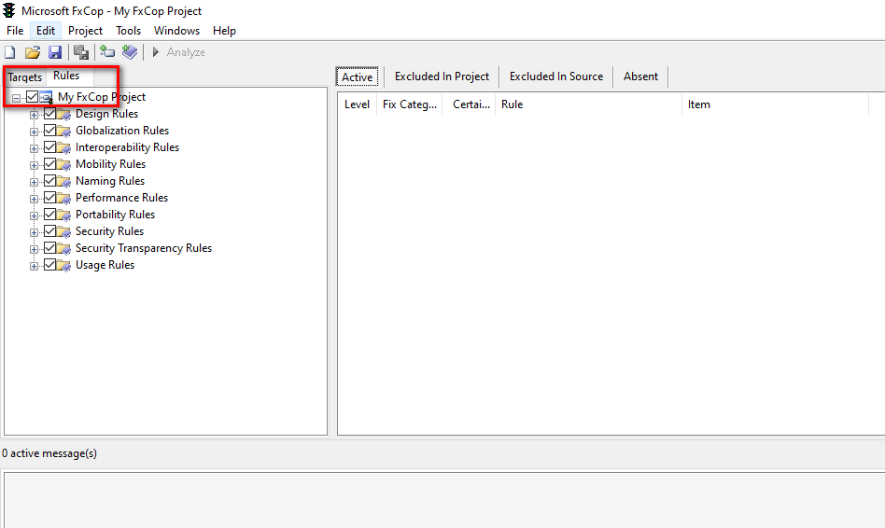

Target indicates the DLL we want to analyse

Rules: set of rules to be check with respect to the target DLL.

What fx cop does is takes a set of rules and then fires o the DLL then provides us with the result of the code review indicating id the code written by us adhere to the policies.

**Creating a custom rule:**

Steps goes as follows

1. Create a class library project using VS
2. Refer fxcopSdk.dll inside this project refer the Microsoft.FxCop.Sdk reference inside your project.
3. Extend BasicInterspectionRule Class
4. And override Check method